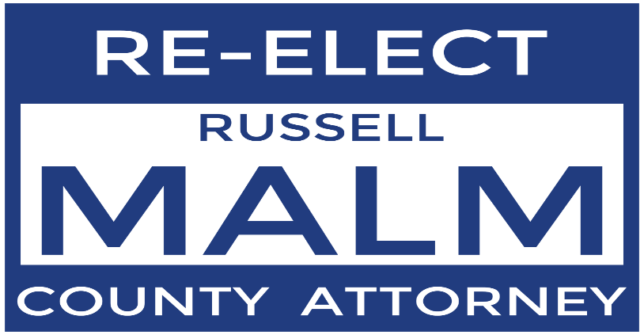

PRESS RELEASE
For Immediate Release Contact: Russell Malm
November 7, 2019 (432)349-6519
russwm@icloud.com

Malm Announces 2020 Re-election Campaign

MIDLAND – Russell Malm announced today he will seek re-election to the office of Midland County Attorney as a Republican.

“The voters of Midland County have generously allowed me to serve as their County Attorney for the past 22 years,” said Malm. “I would be honored to continue to serve them for the next 4 years with the same integrity, honesty, and commitment to the law.”

Malm was first elected County Attorney in 1996. During his career in office he has served as the primary legal advisor to all Midland County elected and appointed officials and has attended over 500 meetings of the Midland County Commissioners Court.

Malm has successfully represented Midland County and its officials and employees in more than 50 lawsuits in state and federal Courts.

Malm will not be soliciting or accepting campaign contributions. He instead urges his supporters to consider making donations to local charities.

